Title: Aggregate Supply
Subject: MTP 7

1. Model to deduce Aggregate supply  A. Demand for labor  a. Assumptions  b. Market setting  c. Production possibilities  d. Market Demand  e. Profits  f. Profits Optimization under constraints  B. Supply of labor  a. Household’s Utility  b. Households’ BC  c. Utility Optimization under BC | Last lecture we deduced Demand for goods market, we now deduce Supply to find the mkt equilibrium.  *Note: you can optimize by Lagrangian or always also by substitution (substitute out variables you don’t need)  Key Assumption: Prices are sticky  Firms do not instantly adjust prices in response to changes in AD  – Prices may be set by long-term contracts between firms and customers  – Firms may decide to change prices only infrequently simply not to annoy their customers  – Once a firm has printed and distributed its catalog it is costly to alter prices  price stickiness assumption leads us to a monopolistically competitive mkt (imperfect market) where firms have some pricing power  General setting for the market  There is a large number of identical firms. Firms are too small to affect prices but they still have some power to set a price that deviates from the MC. Each firm produce a differentiated good, with some degree of substitutability. They take aggregate price level as given but set their own slightly different prices (as in Klugman model).  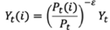  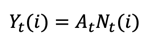  Production possibilities: firm i produces output Yt(i) using labor Nt(i) with Labor productivity At:  They face the following demand for their product:  Pt(i) is price set by firm i, Pt is aggregate price level, and ε>1 is elasticity of demand, captures substitutability (in perf. comp e = +inf)  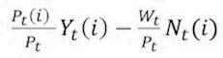  Profits are equal to:  Optimization: Maximize profits s.t. production possibilities and market demand  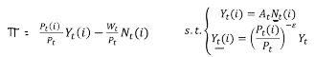  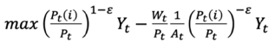  endogenous to the firm: Pt(i), Yt(i) and Nt(i)  i. Substitute N from i) then Yt(i) from ii) (you are removing the other two endogenous variables):  ii. FOC: optimize the equation wrt Pt(i) to derive 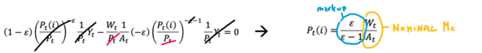  we are not in perfect comp: here ε < +inf --> markup > 1 --> π are positive. Crucial: positive π allow for sticky prices. Sticky prices means firms’ position will be suboptimal --> however there is still some margin to operate. Note: ε in perf comp is +inf --> markup = 1 and P(i) = $\frac{W}{A}$ (π = 0)  Note: Nominal wage: W, Real wage: W/P, Nominal marginal cost: W/A, Real marginal cost (real wage): $\frac{W/P}{A}$  Households obtain utility from consuming goods and suffer disutility from supplying labor.  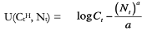  a is the number of hours worked. With a > 1, why a? work creates increasing marginal disutility (to convince workers to work more you will need to raise their wages at an increasing rate, mc is increasing) + divide by a a normalization to make things easier  BC:  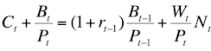  Optimization: Maximize Utility under BC  C, t endogenous  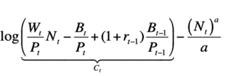  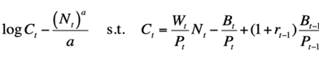  i. substitute C into the objective function:  ii. Take FOC wrt N (*chain rule applied)  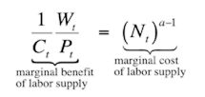    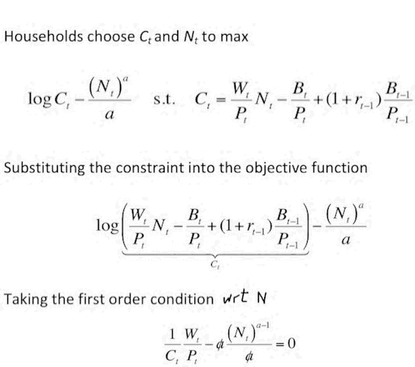  MB: if you work 1 more hr you get a certain Wage increases utility by Mu * w  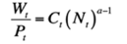  Note: real wages or W/C at optimal N*  iii. Rewrite  Considering: Ct = Yt and Yt = AtNt ---> $\frac{W_{t}}{P_{t}}= {\left(\frac{Y_{t}}{A_{t}}\right)}^{a}A_{t}$  Note; The real marginal cost is equal to the real wage divided by productivity A, hence: MC = $\frac{Y_{t}^{α}}{A_{t}^{α }}$  If we now want to compute the elasticity of the real marginal cost to output, we compute $\frac{ Δ MC}{ Δ Y}$ * $\frac{Y}{MC}$ e = $\frac{αY^{α-1}}{A_{t}^{α}}* \frac{Y}{\frac{Y_{t}^{α}}{A_{t}^{α }}}=α$  As Output increases by 1% the real marginal cost will increase by a%. This is a typical result (increasing costs at the margin) in models where we do not have internal economics of scale.

